Chapter 13, Problem 51.

Use the concept of reflected impedance to find the input impedance and current I₁ in Fig. 13.116 below.

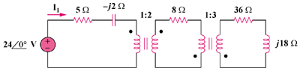

Figure 13.116
For Prob. 13.51.

